CALL TO JOIN GLOBAL AIRPORT ACTIONS
We of the Global Anti-Aerotropolis Movement (GAAM) are helping to mobilize for a ‘Global Action Week: Stay Grounded. Aviation Growth Cancelled Due to Climate Change’ - an initiative spearheaded by Vienna-based System Change Not Climate Change coordinated by Finance and Trade Watch Austria (see Annex 1). The event is taking place end of September/beginning of October to coincide with the annual assembly of the UN aviation organization (ICAO) in Montreal, and we do hope that groups and individuals from all continents will join in to say NO to more aviation growth and airport expansion projects.
So far, major actions are planned in Vienna, London, Mexico City, Notre-Dame-des-Landes, (near Nantes, France) and Istanbul. Mexican activists fighting a destructive aerotropolis project near Mexico City have already come up with a very impressive programme (see Annex 2).
Any input – big or small – will help to make a difference. Activities may vary from public awareness raising campaigns (e.g. by producing articles, statements, petitions; photos/videos; writing letters to concerned authorities/companies etc.); meetings to discuss the issues; photo exhibitions; artistic performances (street theatre, concerts); family-friendly peaceful walks; tree-planting events and flash mobs to protest rallies.
We also encourage concerned groups and citizens to sign on and share the global petition, called No aviation Growth. No false climate solutions, posted at http://www.ftwatch.at/globale-flug-kampagne/.
Undoubtedly, aviation is a massively polluting industry and one of the fastest growing sources of carbon emissions. Yet, climate change is still conspicuously absent from any discussion around aviation growth. It was also excluded from the Paris Agreement signed by the world’s nations at the UN conference (COP21) last December. Therefore, we believe it is high time to step up public pressure at the global level to stop unnecessary and destructive airport expansion schemes; to ensure that aviation is included in all climate change agreements, targets and regulations; and to achieve actual reductions in aviation emissions instead of false solutions, such as ‘offsetting’ projects and biofuels.
Well aware of the criticisms, the aviation industry is making all-out efforts to make sure that discussions at the forthcoming ICAO assembly will focus on how aviation supports ‘sustainable development’. The Air Transport Action Group (ATAG), for example, has published a glossy, image-cultivating report, entitled ‘Aviation: Benefits beyond borders’ (July 2016) that provides good insight into the industry’s green-washing attempts and among other things makes preposterous claims on how aviation will help to achieve the UN’s sustainable development goals. The full ATAG report can be downloaded at: http://aviationbenefits.org/media/149668/abbb2016_full_a4_web.pdf
The Global Action Week will be a good opportunity for us to preempt the industry’s nonsensical arguments and present ground evidence on how local communities around the world, the environment and our climate are harmed by aviation expansion.
Please let us know your ideas and plans for the Global Action Week! For updates on the campaign, please regularly check: http://systemchange-not-climatechange.at/airport-action-days/
THE GLOBAL ANTI-AEROTROPOLIS MOVEMENT, 9/9/2016
Email: antiaerotropolis@gmail.com
GAAM Twitter
GAAM Facebook page
GAAM on Pinterest
GAAM on YouTube
----------------------------
Annex 1
GLOBAL ACTION WEEK AGAINST AIRPORT PROJECTS:
"STAY GROUNDED. AVIATION GROWTH CANCELLED DUE TO CLIMATE CHANGE."
There are many groups around the world resisting the unnecessary expansion of the destructive aviation industry. We want to connect the struggles and show that we can be strong together. We cannot afford any new airport projects if we are serious about tackling climate change.
Neither aviation nor climate change take any notice of national borders. We stand in solidarity with communities who are also fighting devastating airport projects all over the world.
While all this is going on, the UN agency for aviation (the ICAO), stuffed full of industry lobbyists, will be meeting in Montreal, Canada to discuss how to achieve ‘sustainable growth’. This means failed and false solutions like offsetting, carbon trading and biofuels. Our actions will expose this green-washing for what it is. Find background info at http://systemchange-not-climatechange.at/airport-action-days/ and help spread the global petition called NO AVIATION GROWTH. NO FALSE CLIMATE SOLUTIONS at http://www.ftwatch.at/globale-flug-kampagne/.
Take part in a wave of international action planned around the 1st of October. If you know groups fighting against airports, please contact them/us!
Contact: norunway3@systemchange-not-climatechange.at

Annex 2
GLOBAL ACTION WEEK AGAINST AIRPORT PROJECTS AND AVIATION GROWTH, SEPT./OCT. 2016, MÉXICO
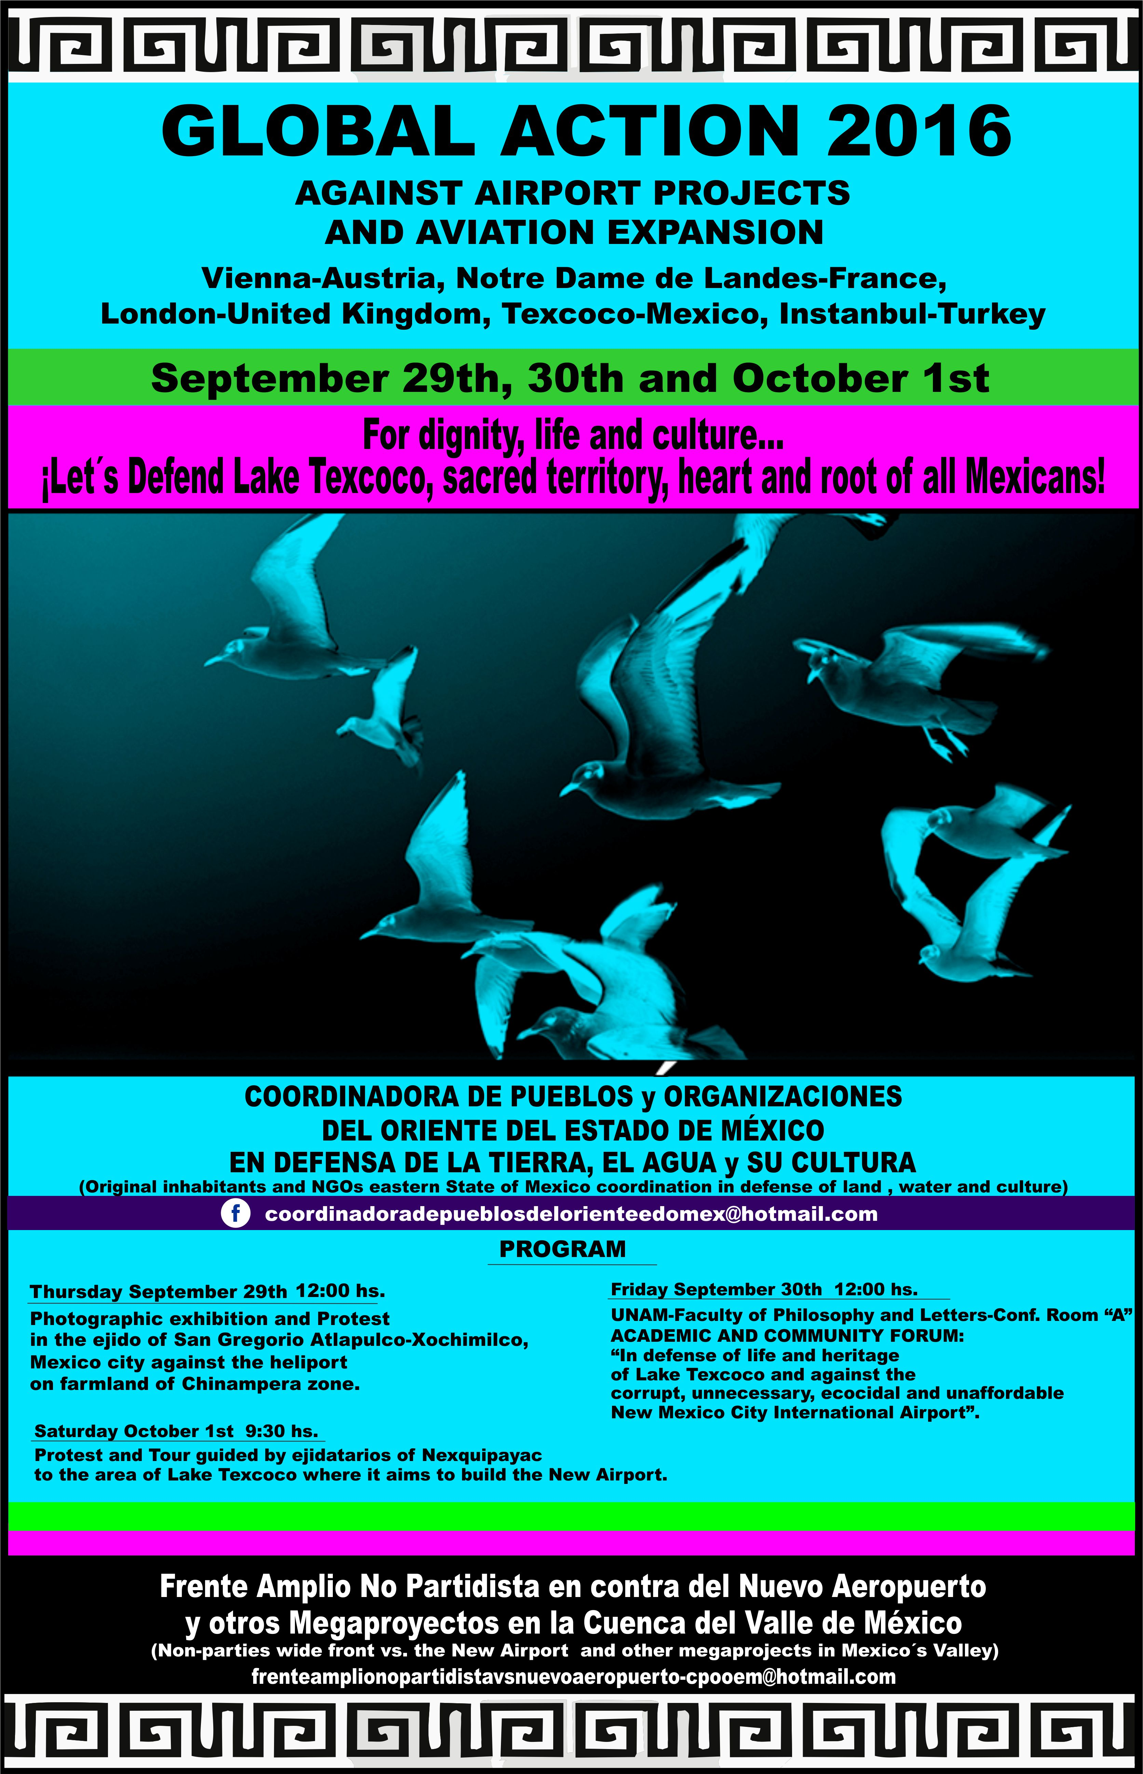
DERIVADO DE LOS PLANES NEOLIBERALES GLOBALES, LAS COMUNIDADES NATIVAS
QUE VIVEN EN LA RIBERA DEL LAGO DE TEXCOCO EN LAS AFUERAS DE LA CIUDAD
DE MÉXICO, HAN EXPERIMENTADO LA REPRESIÓN EXTREMA DEL ESTADO POR
ATREVERSE A RESISTIR LA CONSTRUCCIÓN DE UN NUEVO AEROPUERTO DE SEIS
PISTAS EN SUS TIERRAS.
SU VALOR Y FIRMEZA Y EL APOYO SOLIDARIO DE ONG’S, COMUNIDADES
INDÍGENAS Y PUEBLOS DE MÉXICO Y EL MUNDO, LOGRARON EN EL AÑO 2002
PONER FIN A LOS PLANES ORIGINALES, PERO AHORA EL PROYECTO HA SIDO
RETOMADO Y PARA IMPONERLO, EL ESTADO MEXICANO EN SUS TRES NIVELES DE
GOBIERNO HA CAMBIADO LA ESTRATEGIA: VIENEN MODIFICANDO LEYES, CON LA
AYUDA DE LOS PARTIDOS POLÍTICOS Y CON DINERO COMPRA CONCIENCIAS Y
DIVIDE A LA POBLACIÓN ORIGINARIA, ESTÁ REGALANDO PARTE DE NUESTRO
TERRITORIO A GRUPOS DE CHOQUE AFINES QUE SE INFILTRAN PARA FACILITAR EL
SOMETIMIENTO DE GRANDES PUEBLOS Y EL DESPOJO DE SU TERRITORIO Y ESTÁ
REPRIMIENDO NUEVAMENTE CON EL USO DE LA FUERZA PÚBLICA, A QUIENES A
PESAR DE ESTA GUERRA SUCIA, RESISTIMOS.
HOY LAS COMUNIDADES Y PUEBLOS DE TODA LA CUENCA DEL VALLE DE MÉXICO
NOS HEMOS COORDINADO Y HACEMOS NUEVAMENTE UN LLAMADO A SALVAR LA VIDA DE
NUESTROS PUEBLOS, DE LA CIUDAD DE MÉXICO Y DEL LAGO DE TEXCOCO, SU
RIQUEZA NATURAL, SU IDENTIDAD, PATRIMONIO HISTÓRICO Y LEGADO CULTURAL;
Y A EVITAR LA PÉRDIDA DE LA PRODUCCIÓN DE ALIMENTOS, EL AUMENTO EN LA
TEMPERATURA, EL COLAPSO HÍDRICO Y AMBIENTAL, Y EL EXTERMINIO.
UN NÚMERO DE EVENTOS ESTÁN PLANEADOS LOS DÍAS 29 Y 30 DE SEPTIEMBRE
Y 1° DE OCTUBRE, QUE INCLUYEN REUNIONES PÚBLICAS, UN FORO ACADÉMICO Y
UNA VISITA ALREDEDOR DEL ÁREA AFECTADA GUIADA POR EJIDATARIOS
(CAMPESINOS).

--------------------------
TRADUCCIÓN AL INGLÉS
MEXICO
DUE TO GLOBAL NEOLIBERAL PLANS, NATIVE COMMUNITIES LIVING ON THE SHORES
OF LAKE TEXCOCO OUTSIDE MEXICO CITY HAVE EXPERIENCED EXTREME STATE
REPRESSION FOR DARING TO RESIST THE CONSTRUCTION OF A SIX-RUNWAY NEW
AIRPORT ON THEIR LAND.
THEIR COURAGE AND FIRMNESS, WITH SOLIDARITY AND SUPPORT OF NGOS,
INDIGENOUS COMMUNITIES AND PEOPLE OF MEXICO AND THE WORLD, IN 2002
MANAGED TO STOP TO THE ORIGINAL PLANS, BUT THE PROJECT HAS NOW BEEN
REVIVED AND TO IMPOSE IT, THE MEXICAN STATE, IN THEIR THREE GOVERNMENT
LEVELS HAVE CHANGE THEIR STRATEGY: THEY ARE MODIFYING LAWS, WITH THE
HELP OF POLITICAL PARTIES AND MONEY THEY ARE BUYING CONSCIENCES AND
DIVIDING THE ORIGINAL POPULATION, THEY ARE GIVING AWAY OUR LAND TO
OPPOSING GROUPS RELATED TO THEM, THAT INFILTRATE US TO FACILITATE THE
SUBMISSION OF LARGE TOWNS AND THE DISPOSSESSION OF OUR TERRITORY, AND
THEY ARE REPRESSIVELY ATTACKING US AGAIN WITH THE USE OF PUBLIC FORCE,
AGAINST THOSE WHO DESPITE THIS DIRTY WAR, CONTINUE RESISTING.
TODAY THE COMMUNITIES AND TOWNS ACROSS THE VALLEY OF MEXICO HAVE
COORDINATED AND WE AGAIN CALL TO SAVE THE LIFE OF OUR TOWNS, OF MEXICO
CITY AND TEXCOCO LAKE, THEIR NATURAL WEALTH, IDENTITY, HISTORICAL
HERITAGE AND CULTURAL LEGACY, AND TO AVOID LOSS OF FOOD PRODUCTION,
TEMPERATURE INCREASE, THE WATER AND ENVIRONMENTAL COLLAPSE AND
EXTERMINATION.
A NUMBER OF EVENTS ARE PLANNED FOR SEPTEMBER 29TH AND 30TH AND OCTOBER
1ST INCLUDING PUBLIC MEETINGS, AN ACADEMIC FORUM AND A VISIT AROUND THE
AFFECTED AREA GUIDED BY EJIDATARIOS (FARMERS).

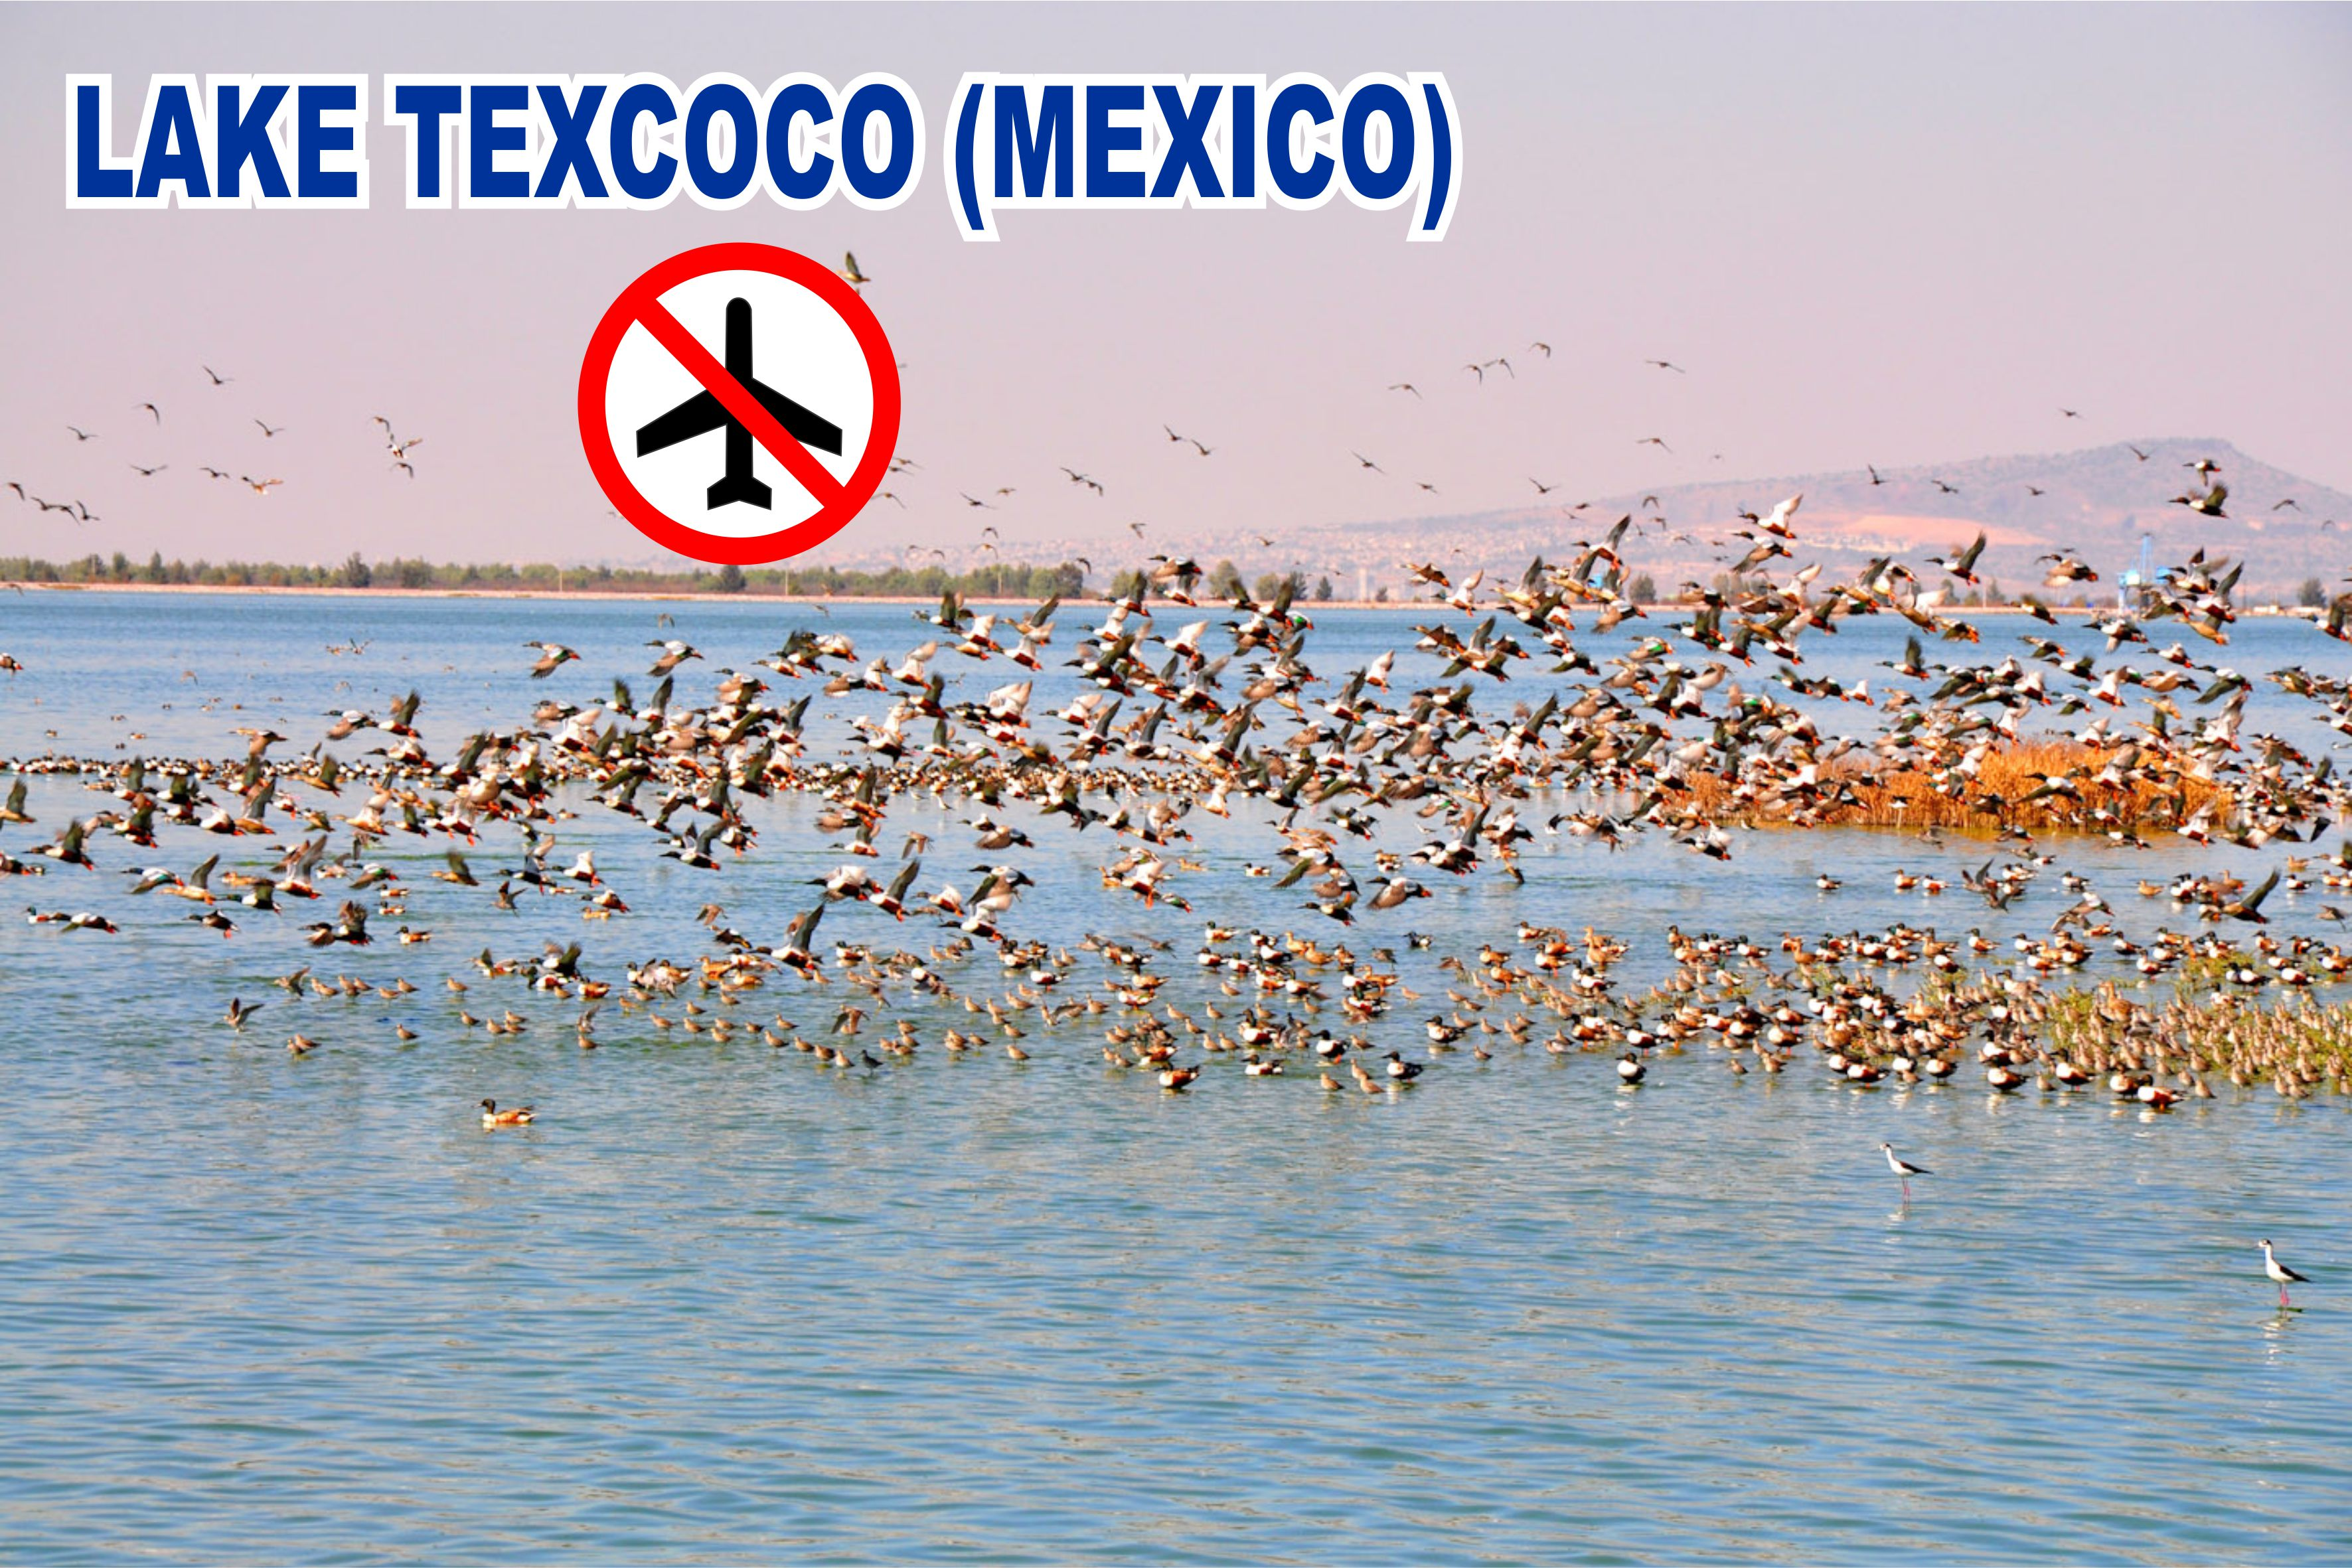

---------------------------
TRADUCCIÓN AL FRANCÉS
MEXIQUE
EN RAISON DES PLANS GLOBAUX NÉOLIBÉRAUX, LES COMMUNAUTÉS AUTOCHTONES
VIVANT SUR LES RIVES DU LAC TEXCOCO EN DEHORS DE LA VILLE DU MEXIQUE ONT
CONNU ÉTAT EXTRÊME RÉPRESSION POUR AVOIR OSÉ RÉSISTER À LA
CONSTRUCTION D’UN NOUVELLE AÉROPORT DE SIX PISTES SUR LEUR
TERRITOIRE.
LEUR COURAGE ET FERMETÉ, AVEC LA SOLIDARITÉ ET LE SOUTIEN DES
ORGANISATIONS NON GOUVERNEMENTALES, LES COMMUNAUTÉS AUTOCHTONES ET LES
PERSONNES DU MEXIQUE ET DU MONDE, EN 2002, A RÉUSSI À ARRÊTER LES
PLANS ORIGINAUX, MAIS LE PROJET A MAINTENANT ÉTÉ RAVIVÉ ET POUR
L’IMPOSER, L’ÉTAT MEXICAIN, DANS LEURS TROIS ADMINISTRATIONS ONT
CHANGER LEUR STRATÉGIE: ILS MODIFIENT LES LOIS, AVEC L’AIDE DE PARTIS
POLITIQUES ET DE L’ARGENT ILS ACHÈTENT LES CONSCIENCES ET DIVISANT LA
POPULATION D’ORIGINE , IL DONNE PARTIE DE NOTRE TERRITOIRE À DES
GROUPES CONTRE NOUS QUI LEUR SONT LIÉES, QUI S’INFILTRENT POUR
FACILITER LA SOUMISSION DES GRANDES VILLES ET LA DÉPOSSESSION DE NOTRE
TERRITOIRE, ET ILS NOUS ATTAQUENT AVEC VIOLENCE EN UTILISANT LA FORCE
PUBLIQUE, CONTRE CEUX QUI, EN DÉPIT DE CETTE SALE GUERRE, CONTINUER À
RÉSISTER.
AUJOURHUI LES COMMUNAUTÉS ET LES VILLES À TRAVERS LA VALLÉE DU
MEXIQUE ONT COORDONNÉS ET NOUS APPELONS À NOUVEAU POUR SAUVER LA VIE
DE NOS VILLES, DE LA VILLE DU MEXIQUE ET LAC DE TEXCOCO, LEUR RICHESSE
NATURELLE, IDENTITÉ, PATRIMOINE HISTORIQUE ET PATRIMOINE CULTUREL ET
POUR ÉVITER LA PERTE DE LA PRODUCTION ALIMENTAIRE, AUGMENTATION DE LA
TEMPÉRATURE, L’EAU ET EFFONDREMENT DE L’ENVIRONNEMENT ET
D’EXTERMINATION.
UN CERTAIN NOMBRE DE MANIFESTATIONS EST PRÉVU POUR LE 29 ET 30
SEPTEMBRE ET 1ER OCTOBRE, ET AUSSI DES RÉUNIONS PUBLIQUES, UN FORUM
ACADÉMIQUE ET UNE VISITE AUTOUR DE LA ZONE TOUCHÉE, GUIDÉE PAR LES
"EJIDATARIOS" (FERMIERS).

*********

